Week 2 session 9 Stream & Pipeline Processing
1.group Anagrams
import java.util.*;

class Solution {
public List<List<String>> groupAnagrams(String[] strs) {

HashMap<String, List<String>> map = new HashMap<>();

for (String str : strs) {

// Convert string to character array
char[] chars = str.toCharArray();

// Sort characters
Arrays.sort(chars);

// Convert sorted characters back to String
String key = new String(chars);

// Add string to the corresponding group
if (!map.containsKey(key)) {
map.put(key, new ArrayList<>());
}

map.get(key).add(str);
}

return new ArrayList<>(map.values());
}
}
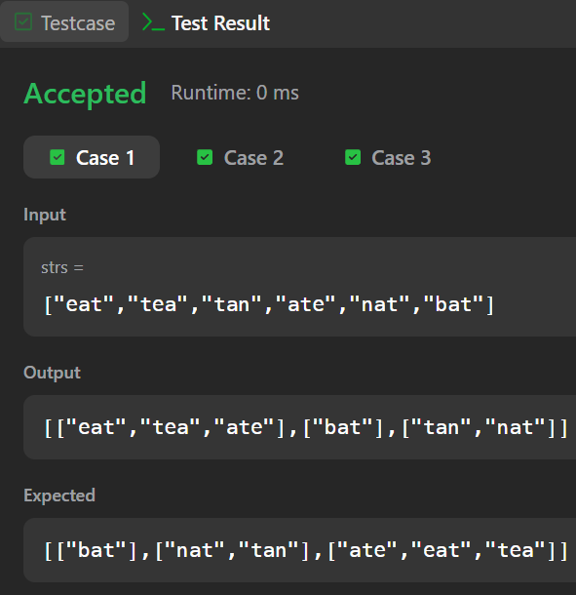
2. Top K Frequent Elements
import java.util.*;

class Solution {
public int[] topKFrequent(int[] nums, int k) {

// Step 1: Count frequency
HashMap<Integer, Integer> map = new HashMap<>();

for (int num : nums) {
map.put(num, map.getOrDefault(num, 0) + 1);
}

// Step 2: Create buckets
List<Integer>[] buckets = new List[nums.length + 1];

for (int num : map.keySet()) {

int frequency = map.get(num);

if (buckets[frequency] == null) {
buckets[frequency] = new ArrayList<>();
}

buckets[frequency].add(num);
}

// Step 3: Get top k elements
int[] result = new int[k];
int index = 0;

for (int frequency = buckets.length - 1;
frequency >= 0 && index < k;
frequency--) {

if (buckets[frequency] != null) {

for (int num : buckets[frequency]) {

result[index] = num;
index++;

if (index == k) {
break;
}
}
}
}

return result;
}
}
